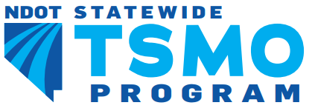
TSMO Steering Committee (TSC)
Meeting Agenda
Project: | NDOT Statewide TSMO Implementation
Subject: | TSMO Steering Committee (TSC) Meeting
Meeting place: | Microsoft Teams | Meeting no: | 3
Date and time: | 18 May 2021 | 02:00 PM

ITEM | DESCRIPTION | RESPONSIBLE
 | Introductions | LaShonn Ford – NDOT
 | TSMO Website Updates | Mohan Garakhalli – Atkins
 | TSMO Performance Management Program | Steve Hoover – Atkins
 | TSMO Staffing and Workforce Development Plan | Ati Abad – Atkins
 | Feedback on the TSMO Business Case for Divisions | Mohan Garakhalli – Atkins
 | Final Remarks | LaShonn Ford – NDOT

